Cairo University  
Faculty of Computers and Information



**CS251**

**Software Engineering I**

EduGaming

November 2016

# Team

|  |  |  |  |
| --- | --- | --- | --- |
| **ID** | **Name** | **Email** | **Mobile** |
| 20140116 | Rami Mohamed | ramimohamedsalah96@gmail.com | 01149273153 |
| 20140109 | Khaled yousef | khaledyousef196@gmail.com | 01114300109 |
| 20140056 | Islam Emam | islam.emmo@gmail.com | 01127321234 |
| 20140128 | Remon Atef | remonatef128@yahoo.com | 01285129556 |

# Document Purpose and Audience

Project declaration and Showing a dynamic design for how the system should work.

Audience : Computech Project Manager.

# Introduction

## Software Purpose

## Creating link between students and teachers through simple educational -games.Software Scope.

## Software Scope

A teacher–student website that can teach students two different fields programming and science, By developing some simple tools that can be dragged and dropped as for science field and by writing simple codes as for programming to help teacher create his game.

## 

## Definitions, acronyms, and abbreviations

|  |  |
| --- | --- |
| **Definition** | **Description** |
| fps | Frame per second |

# Requirements

## Functional Requirements

Website must categorize user type to check if user is teacher or student.

Any user can select the category of games.

Guest can surf the website and try any game.

Student user can play the games he/she wants.

Teacher user can develop & play games.

## Non Functional Requirements

User authentication and validation in user’s login.[reliability]

System Should differentiate between Student and Teacher in Interface.[usability]

System must respond to teacher that game has been saved correctly when he tries saving.[reliability]

When teacher tries to leave without saving system must double check his desire.[reliability]

Server must be stable and available for use any time.[reliability]

User’s ability to report for website problems.[supportability]

System’s quick response to any problem.[supportability]

System loads games with rate higher than 30 fps.[performance]

# System Models

## Use Case Model

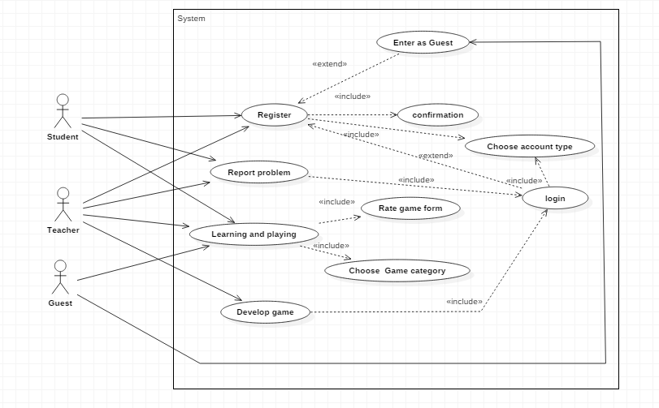

## Use Case Table

|  |  |  |
| --- | --- | --- |
| Use Case ID: | 1 | |
| Use Case Name: | Registration | |
| Actors: | Student ,Teacher | |
| Pre-conditions: | Visit website | |
| Post-conditions: | Valid registration confirmed. | |
| Flow of events: | **User Action** | **System Action** |
| 1- Make register request |  |
|  | 2- System loads registration type selection page |
| 3-Choose registration type |  |
|  | 4-System loads registration page |
|  | 5- Enter personal information and authentication |  |
|  |  | 6- System check for validation and redirect to login page |
| Exceptions: | **User Action** | **System Action** |
| 1. Enter personal information and authentication [invalid or used information] |  |
|  | 2- Highlight invalid data in registration.  (e.g. username invalid) |
|  | 1- Enter as a guest. |  |
|  |  | 2- System postpones registration. |
| Includes: | Confirmation. | |
| Notes and Issues: |  | |

|  |  |  |
| --- | --- | --- |
| Use Case ID: | 2 | |
| Use Case Name: | Learning and playing | |
| Actors: | Student ,Teacher ,Guest | |
| Pre-conditions: | Visit website, Check for registration | |
| Post-conditions: | Game stopped | |
| +Flow of events: | **User Action** | **System Action** |
| 1- Login |  |
|  | 2- System Verifies for login information and redirects to student page. |
| 3- Choose desired category. |  |
|  | 4- System shows games within selected category. |
| 5- Choose desired game. |  |
|  | 6- System starts game. |
| 7-Play game  8-Exit game |  |
|  |  | 9-System redirect to student page. |
| Exceptions: | **User Action** | **System Action** |
| 1- Complete game |  |
|  | 2- System adds achievement. |
|  | 1-Pause game |  |
|  |  | 2-System wait. |
| Includes: | Show game rate message. | |
| Notes and Issues: |  | |

# 

|  |  |  |
| --- | --- | --- |
| Use Case ID: | 3 | |
| Use Case Name: | Build game | |
| Actors: | Teacher | |
| Pre-conditions: | Visit website, Check for registration | |
| Post-conditions: | Save game contents | |
| Flow of events: | **User Action** | **System Action** |
| 1-login. |  |
|  | 2- System Verifies for login information and redirects to teacher page. |
| 3-Build desired game.  4-Save game to a specific category. |  |
|  | 5-System adds the game to the student page and redirects to teacher page. |
| Exceptions: | **User Action** | **System Action** |
| 1- Close website before saving game. |  |
|  | 2- System pops up a warning message assuring user's intent to close website without saving. |
| Includes: | Save game. | |
| Notes and Issues: |  | |

|  |  |  |
| --- | --- | --- |
| Use Case ID: | 4 | |
| Use Case Name: | Report a problem | |
| Actors: | Student ,Teacher | |
| Pre-conditions: | Login. | |
| Post-conditions: | Problem solved. | |
| Flow of events: | **User Action** | **System Action** |
| 1. Make report ticket. |  |
|  | 2- System provides report type choices. |
| 3-Select report type  4-Write description about the problem and submit it. |  |
|  | 4-System shows message thanking user for submitting report and sends the report for the technicians. |

# Ownership Report

|  |  |
| --- | --- |
| **Item** | **Owners** |
| Document Purpose and Audience | *Remon Atef* |
| Software Purpose | *Khaled Yousef* |
| Software Scope | *Khaled Yousef* |
| Definitions, acronyms, and abbreviations | *Rami Mohamed* |
| Functional Requirements | *Remon Atef* |
| Nonfunctional Requirement | *All team members* |
| Use case Model | *All team members* |
| Use case 1 | *Khaled yousef* |
| Use case 2 | *Rami Mohamed* |
| Use case 3 | *Islam Emam* |
| Use case 4 | *Islam Emam* |